**Multi Stage Docker builds**

* To build a docker image we need an application package, we build a application package on the build server and then use it in the docker file to build the application docker image.
* The idea of multi stage builds is to use docker completely to build an application package and create a docker image.
* Lets try to build the docker image for game of life(URL: <https://github.com/wakaleo/game-of-life>) for the code of game of life
* To build this application package we need
  + git to the code
  + java to be installed
  + maven to build the code
* Manual Steps to get the application package:

git clone https://github.com/wakaleo/game-of-life.git

cd game-of-life

mvn package

* Now after the package step is successful, we get the gameoflife.war which can be used in the Dockerfile to build image
* We have a docker image which is preinstalled with maven (Link: https://hub.docker.com/_/maven)
* Dockerfile created and then build the image.

FROM maven:3-jdk-8 AS mvn RUN git clone https://github.com/wakaleo/game-of-life.git && cd game-of-life && mvn package FROM tomcat:8 LABEL author="khaja" LABEL organization="QualityThought" COPY --from=mvn /game-of-life/gameoflife-web/target/gameoflife.war /usr/local/tomcat/webapps/gameoflife.war EXPOSE 8080

docker image build -t gameoflife:1.0 .

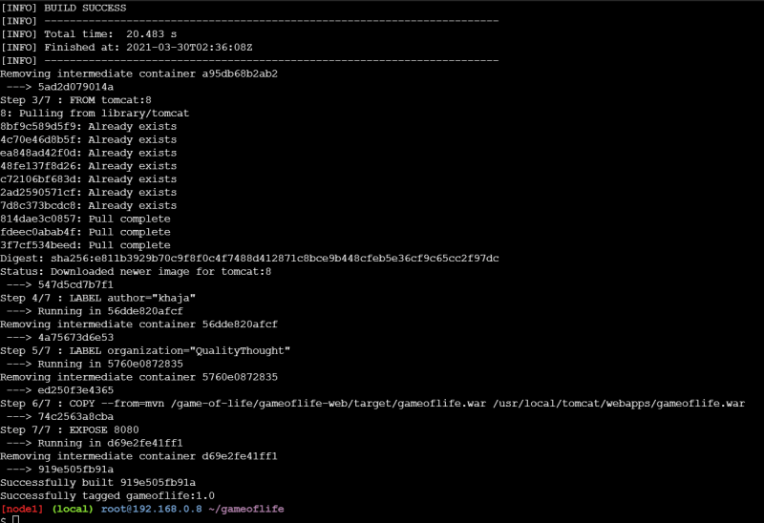

* Docker first tries to build the stages in the above case it will build the mvn stage first and then it builds the docker image with the last FROM which will be what your image will have. the necessary files will be copied from stages into the Docker image depending on instructions
* Lets run the container 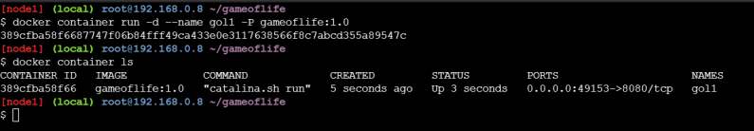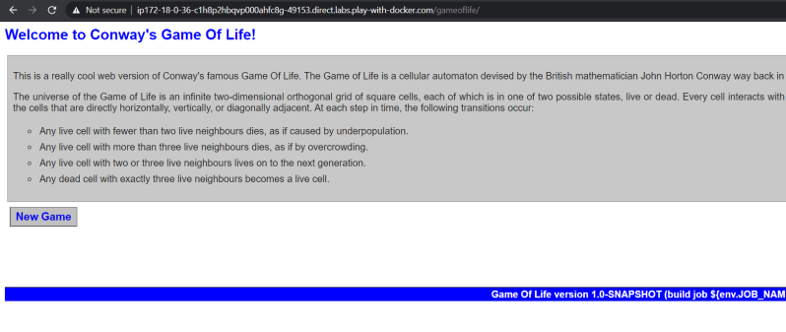
* Now lets try to build one more docker image using the multi staged build
* Spring pet clinic
  + Manual steps for build the package:
* git clone https://github.com/spring-projects/spring-petclinic.git
* cd spring-petclinic
* mvn package
* Docker file and build the image

FROM maven:3-jdk-11 as mvn RUN git clone https://github.com/spring-projects/spring-petclinic.git RUN cd spring-petclinic && mvn package FROM openjdk:11 LABEL author="khaja" COPY --from=mvn /spring-petclinic/target/spring-petclinic-2.4.2.jar /spring-petclinic-2.4.2.jar EXPOSE 8080 CMD ["java", "-jar", "/spring-petclinic-2.4.2.jar"]

docker image build -t spc:1.0 .

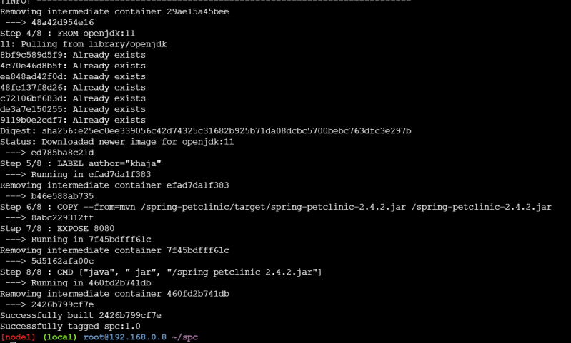

* Now lets run the container 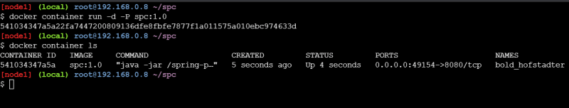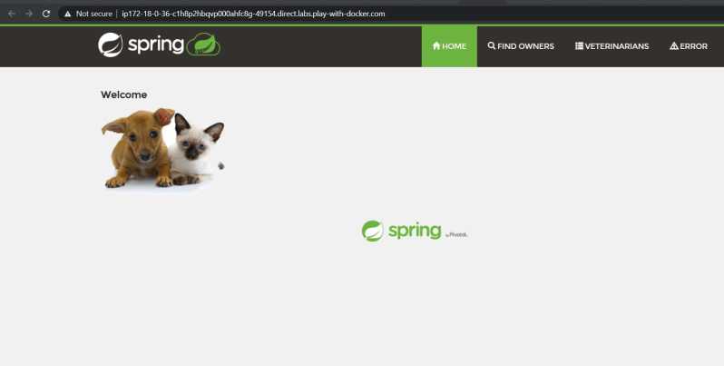

**Install Docker on Linux**

* Ubuntu20:
  + Create a Ubuntu20 vm in any cloud or hypervisor
  + Login into ubuntu and update the packages